Tenterden and District  Local History Society  Founded 25th November 1955 | 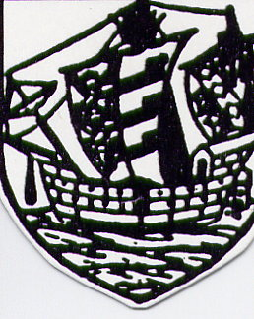 | Newsletter  No. 43  October 2023  www.tenterdenhistory.co.uk

Have a Go visits Tenterden

Have a Go was a BBC Radio show that ran from 1946 to 1967. Hosted by Wilfred Pickles and co-presented with his wife Mabel (née Myerscough). The show toured Britain performing in local halls or canteens in towns and villages. It was accompanied by a pianist on stage who provided musical links and catch tunes. For six years the pianist for the programme was Violet Carson. She was also a celebrated actress who in the last two decades of her life played Ena Sharples in the ITV soap opera Coronation Street. At the start of a show members of the audience would join in to sing the opening chorus.

"Have a go, Joe, come on and have a go, You can't lose owt, it costs you nowt,
to make yourself some dough
So hurry up and join us, don't be shy
and don't be slow.
Come on Joe, have a go!

Volunteers would step up and be interviewed by Wilfred Pickles about their lives before he asked them a general knowledge question in the hope of them winning a small amount of money. It was the first quiz show in Britain to offer such a prize. However, they would receive a prize whether they answered right or wrong, but more if they were right. The question was carried forward to the next contestant if it was answered incorrectly.

Pickles' presentation style resulted in catchphrases such as "How do, how are yer?", "Are yer courting?", "What's on the table, Mabel?" and "Give him the money, Mabel" or "Give him the money, Barney" [Barney Colehan was the producer of the programme in its early days]. There would also often be items of local produce awarded in addition to the money, hence the catchphrase "What's on the table, Mabel?" The programme's popularity was such that at one time it attracted an estimated 20 million listeners weekly.

On Tuesday 7 January 1958 this popular half-hour BBC programme visited the ancient borough of Tenterden. It was a live broadcast – and it was lively. No difficulty whatsoever was encountered in capacity filling the Town Hall for the occasion. Six people were chosen by Mr Stephen Williams, the programme’s producer, to appear for an interview with Wilfred Pickles but their names were not read out until a few minutes before the actual broadcast. They were selected as representing the widest cross-section of the community as possible.

When Wilfred Pickles arrived, bedecked in black coat and yellow waistcoat, he explained to the audience what to do when the “red light” went on. During the last few minutes to “time” Wilfred stripped down to his shirt, yellow braces and trousers and his wife Mabel took her place at the table. The usual buzz that is common to any large audience faded. Headphones on, Stephen Williams was alert, calmness personified, and silently counted out the seconds with Harry Hudson poised at the piano in front of the six rather nervous broadcasters-to-be. The red light flashed on to denote that, for Tenterden, this was it and Tenterden voices chorusing “Come on Joe, have a go!” we’re on the air.

Wilfred opened the show with a typical Pickles crack about the transport difficulties in reaching the town from London. First on was 82-year-old Morphew (people call me “Morf”) Parsons who spoke up confidently about his sheep droving, his family of many brothers and sisters (all had predeceased him), his lack of need of medical attention and his dislike of TV. He was followed by Miss Mary Judge, auctioneer’s clerk in her late father’s business and giving her age as the “dangerous 40s”. She told an appealing story of how her interest in the plight of refugees had been stimulated by the sight of a small boy in Germany in 1950. Burly genial Maidstone & District bus driver Dennis Roberts told of amusing incidents and Mrs Doris Phillips was so excited that she gave her maiden name of Mannerings, which she had discarded the previous summer. Scotsman Pat Wightman, who believes in meeting people, showed he had become so Anglicised during his 12 years in the town that he sang – and remarkably well too – “The English Rose”. Finally came 19 year-old dark-haired bank clerk Miss Jill Holdstock, one of Tenterden’s fairest maids. She told Wilfred she found men better than women for lifts on her hitch-hiking holidays. This Wilfred said was not surprising. For the jackpot question there was a tie between Miss Judge and Mrs Phillips, who shared the spoils of £3, a box of local produce, and some Tenterden lollipops made by Mrs Puxty of Beachy Path for the occasion. The chorus below concluded the broadcast.

Call round any old time and make yourself  at home,  Put your feet on the mantle-shelf,  Tune in your wireless and help yourself,  We don’t care if your friends have left you  all alone,  Rich or poor, knock at the door,  and make yourself at home, | 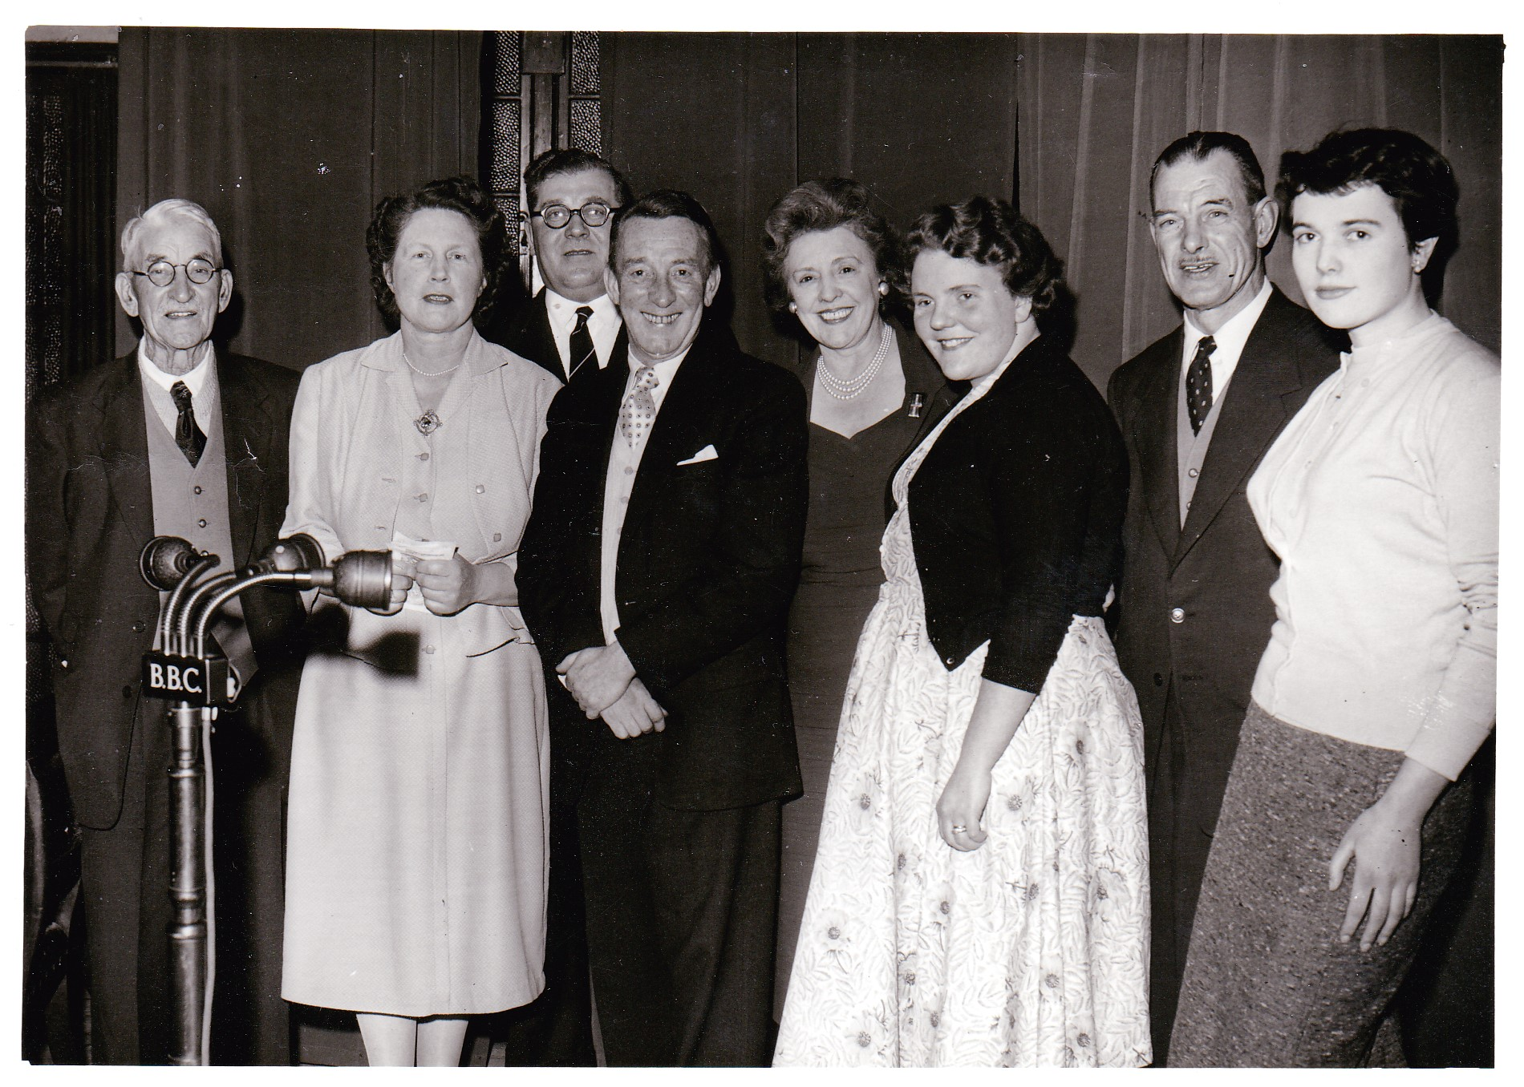
Left to Right: Morphew Parsons, Mary Judge, Dennis Roberts
Wilfred and Mabel Pickles
Doris Phillips, Pat Wightman, Jill Holdstock

The Mayor, Cllr Mrs Nina D Goldsmith, who sat in the audience with Sir John Kotelawala, former Prime Minister of Ceylon (now Sierra Leone), then went on the stage to publicly thank Wilfred and Mabel, the producer and engineers, as well as those who had broadcast, and Mr S Cooper and the Town Clerk for their help.

Wilfred Pickles said the audience had behaved magnificently and he congratulated the six delightful people who had been chosen for the broadcast. They had been simply “grand”. Afterwards the Mayor held an informal reception during which a recording of the programme was played back.

For over an hour prior to the actual broadcast, after an introductory announcement to the audience by Mr Ivo T Emberson (Town Clerk), the Town Hall audience was entertained to a first-class variety performance, in which Harry Hudson (comedy pianist), Joan Small (vocalist), Gwenda Wilkin (accordionist) and Gil Leaney (magician) were the artistes. The last named was “assisted” by Miss Violet Bond, a shorthand-typist in the Town Clerk’s office, who apparently had her leg amputated by a guillotine in full view of the audience!

During a busy morning, Wilfred and Mabel, in company with Harry Hudson and producer Stephen Williams gave a special “junior” version of “Have a Go” at the Church of England Primary School and also at Homewood Secondary School. At each school children in various age groups competed for half-crown prizes and the children at the Primary School were highly amused when at the conclusion Wilfred had a quiz question for the teachers. The question, “How many months have 28 days?” was correctly answered by the Rev CSW Marcon (Vicar of Tenterden) who promptly said “All of them!” Later, accompanied by the Mayor, Wilfred visited the patients of West View Hospital.

References
Kentish Express
The Courier
Jack Gillett

